**ADARSHA VIDYAPEETH,BHOLAGURI**

**HSLC RESULT 2025**

**DISTINCTION:**

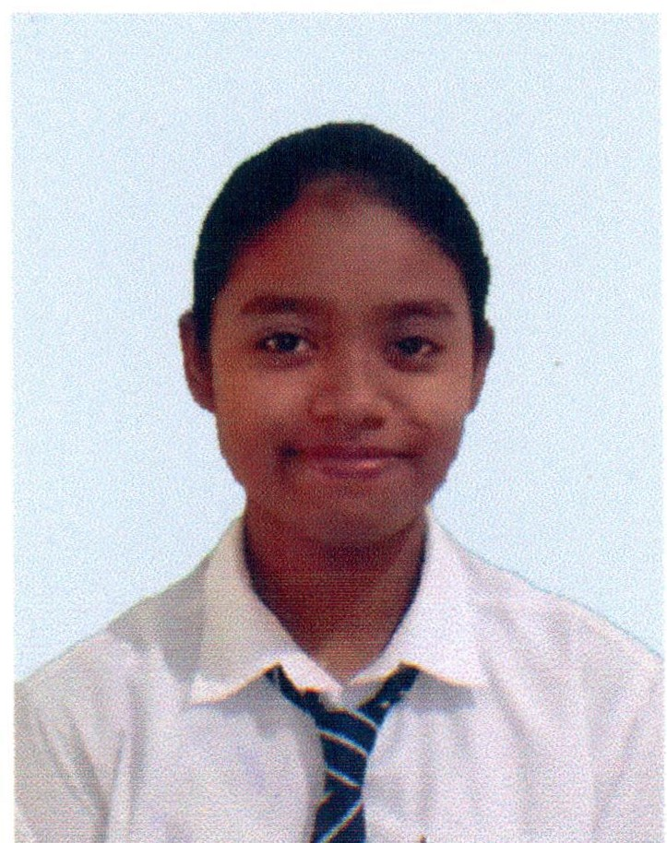



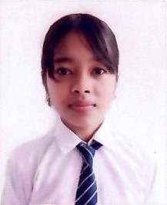

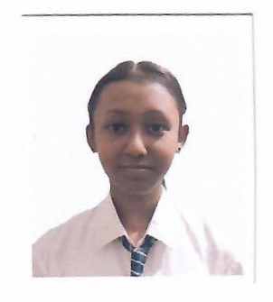

**Jutismita Borah Priyampoli Gogoi Ankita Borah Nistha Borah**

**92 % 89.83% 88.33% 88.17%**

**Star:**

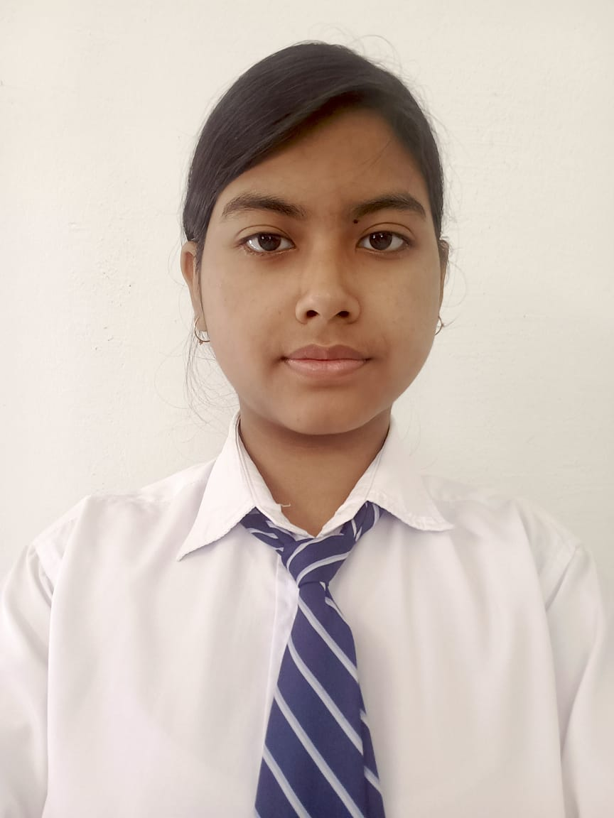

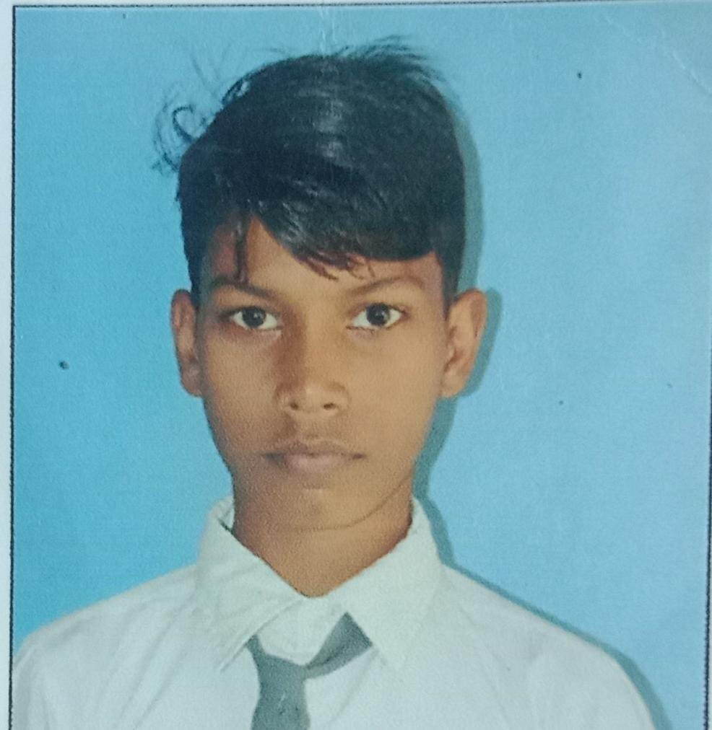

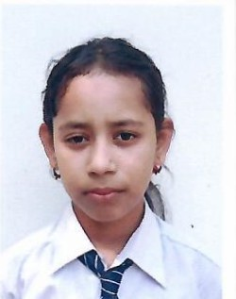

**Bistiti Gogoi Jahnobi Loying Pronami Bhorali Suraj Gupta Madhujya Loying**

**84.33% 83.83% 82.17 81.5% 81.33%**

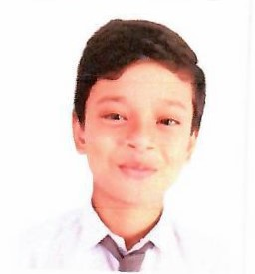

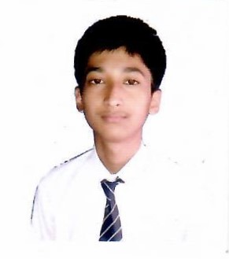

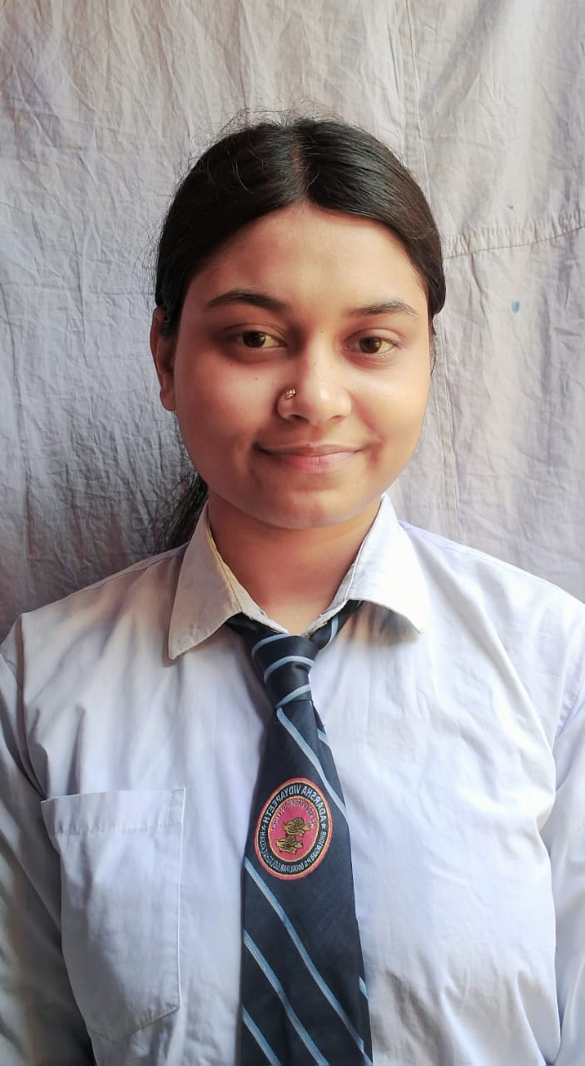

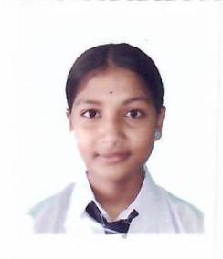

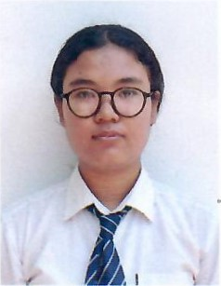

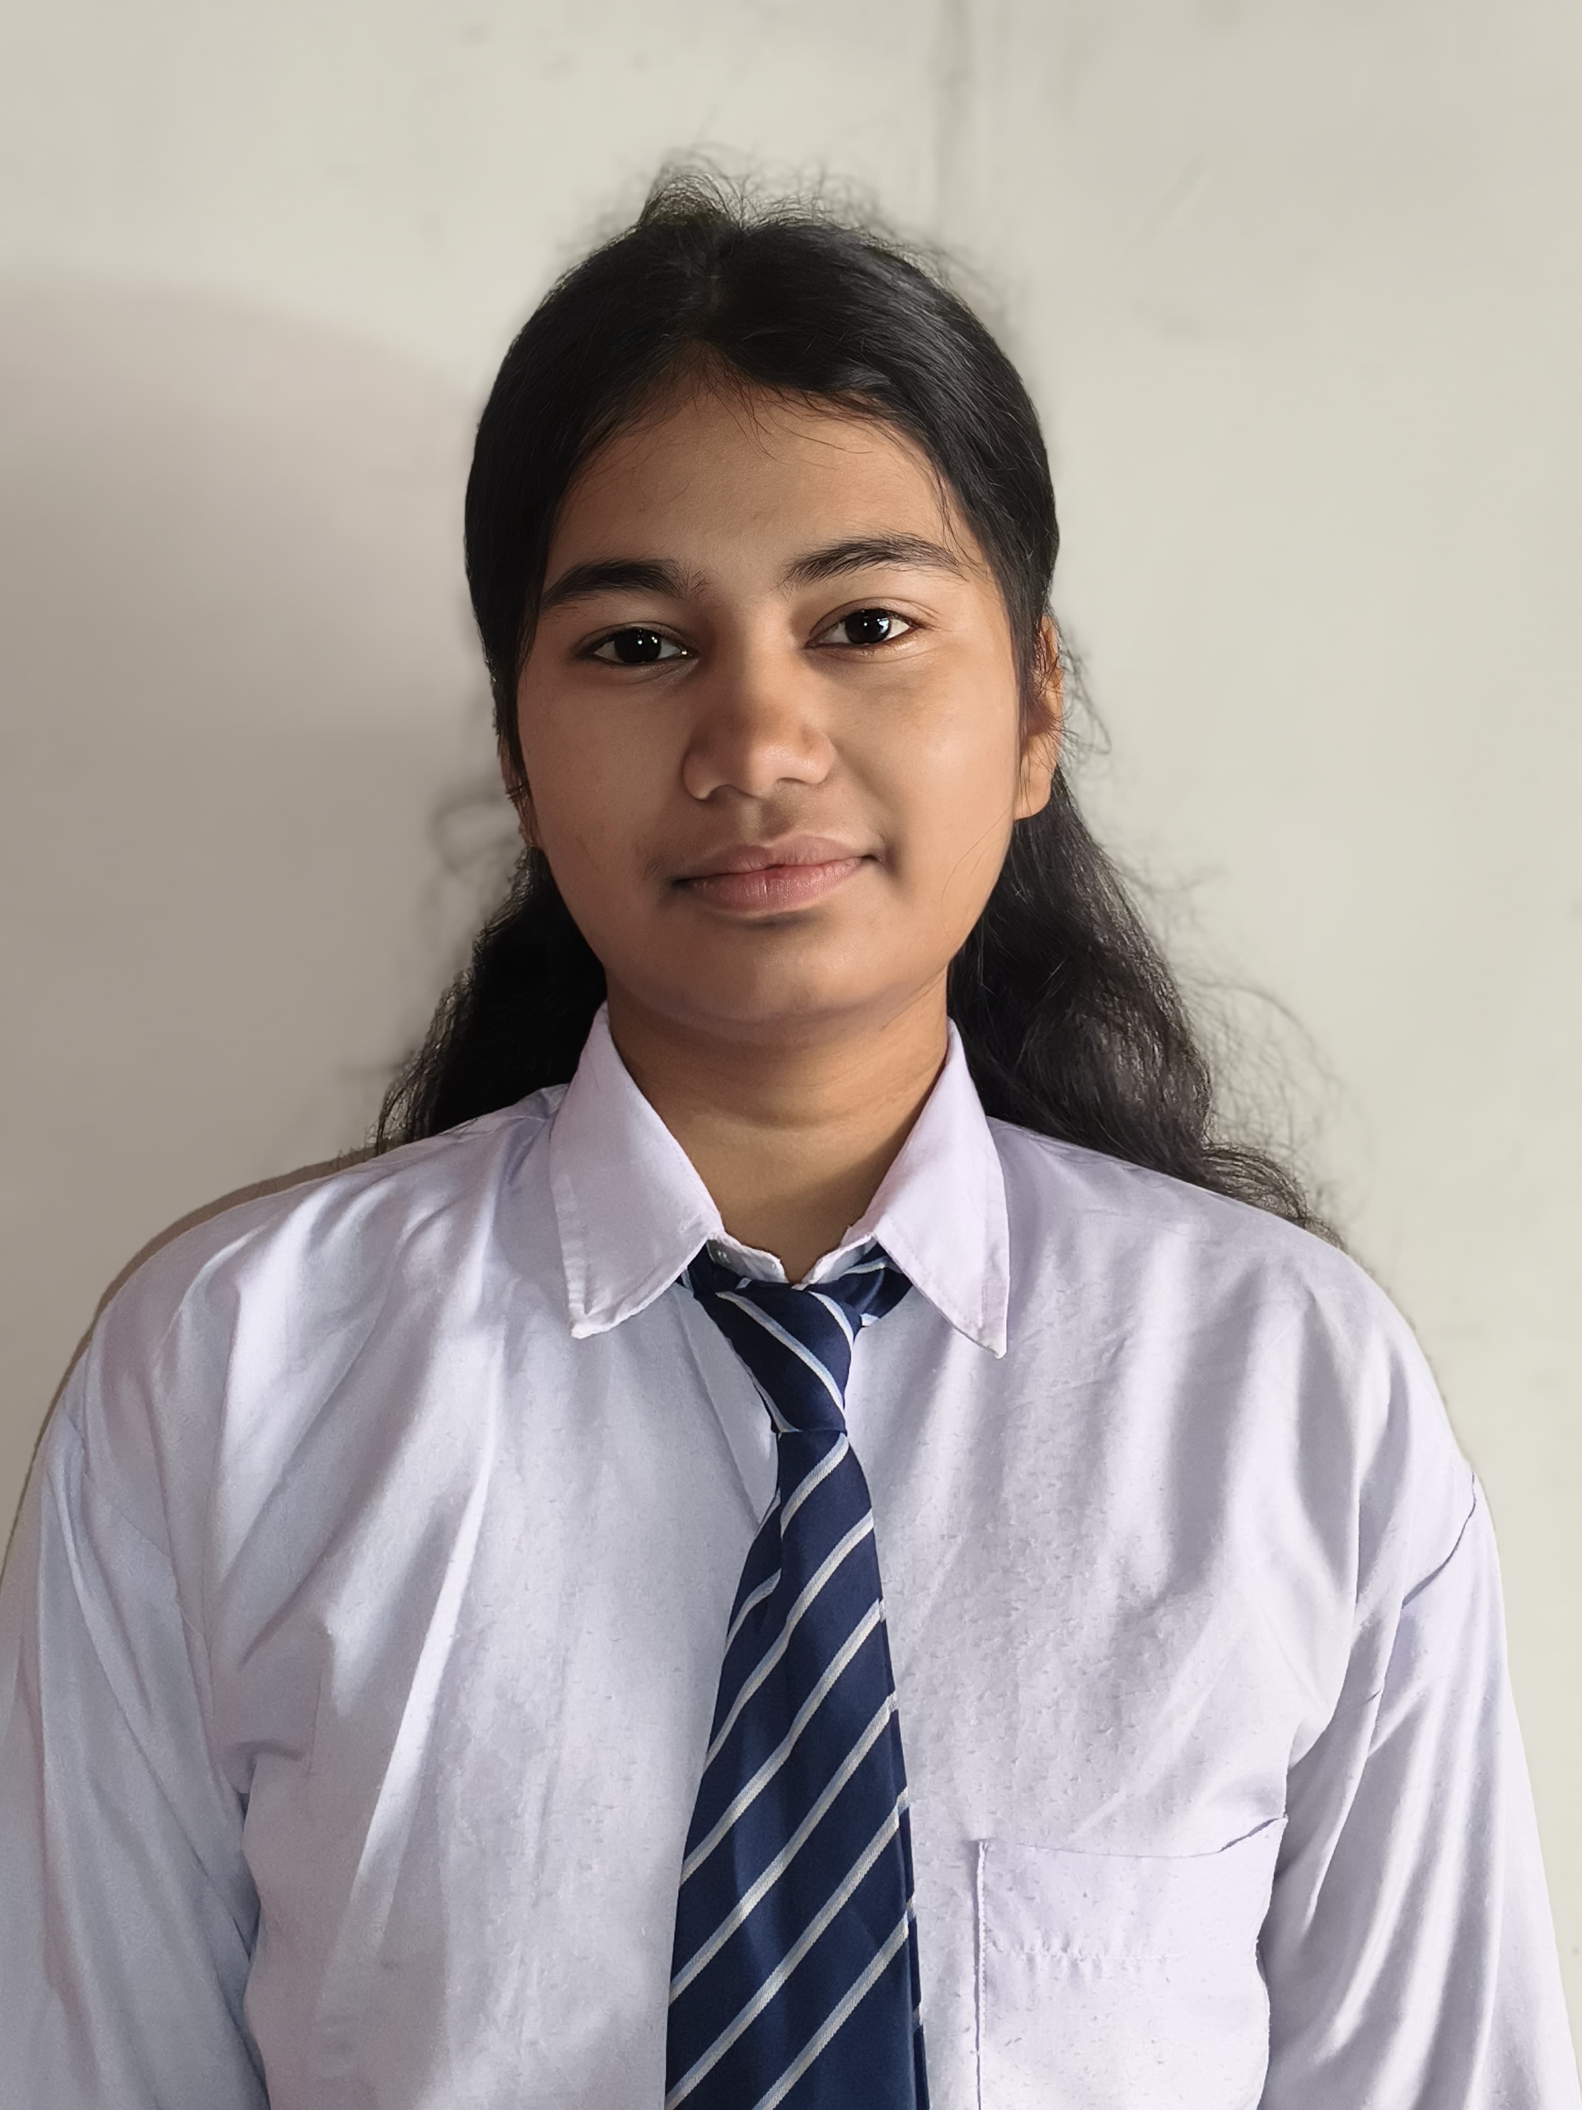

**Porishmita Sahu Chandrali Gogoi Prachi Shah Sunari Kumari Suman Borma Arnabjyoti Gogoi` Debasish Gogoi**

**81.33% 78.33% 78% 78% 77.17% 75.17%**

**1st Division:**



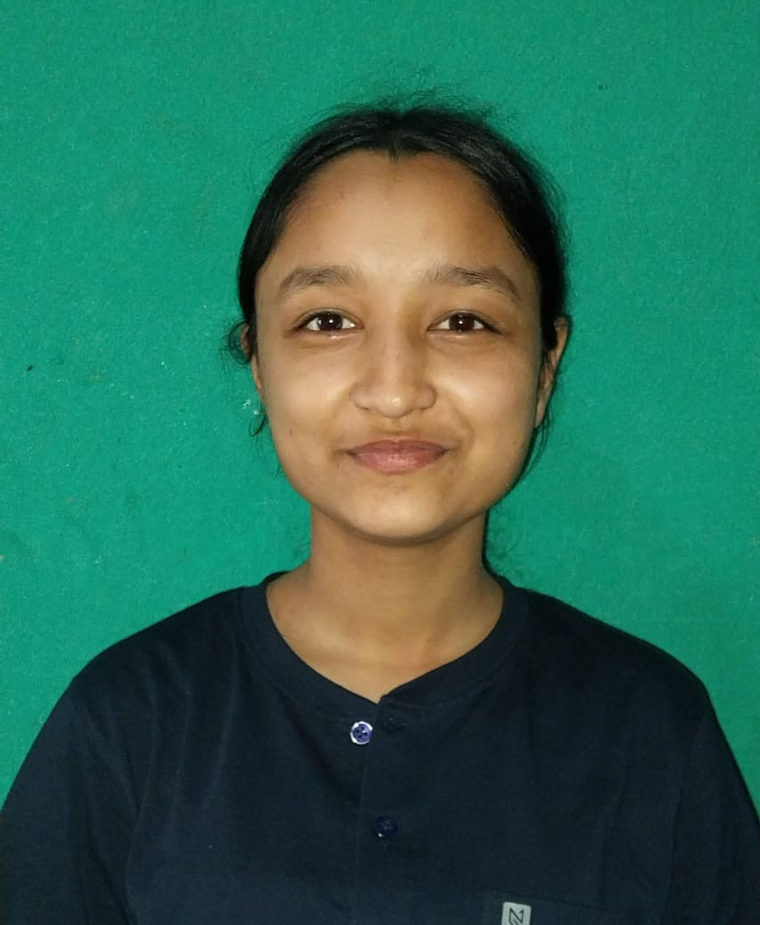

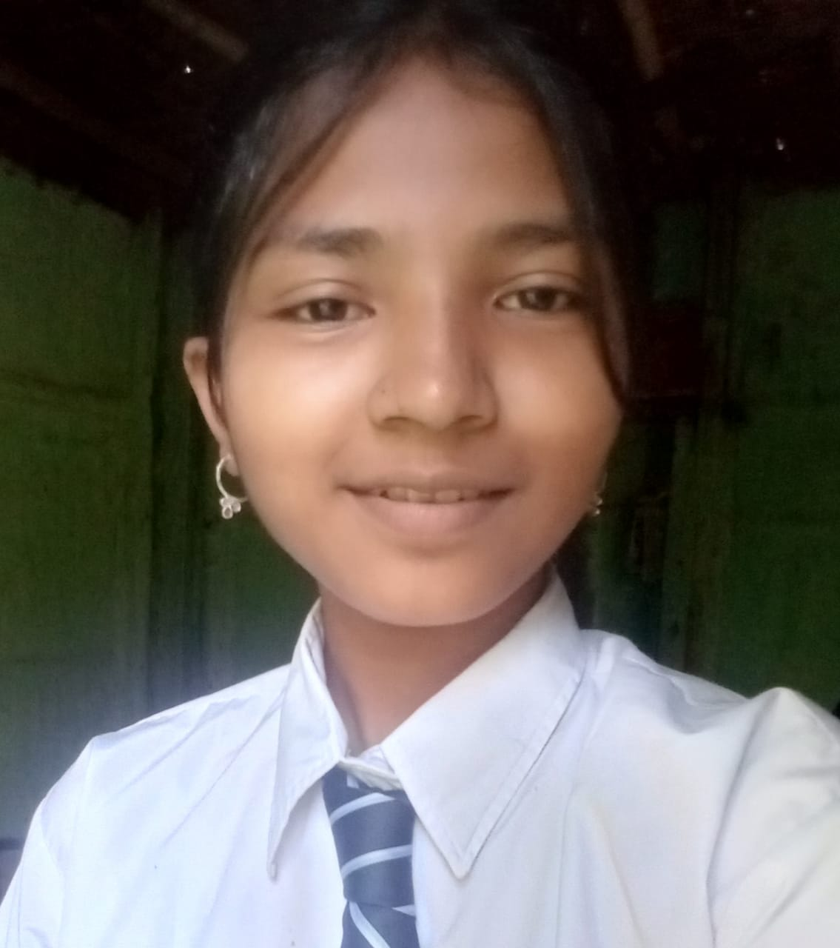

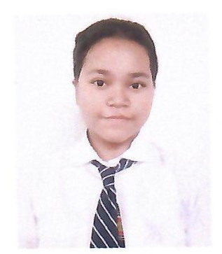

**Dristihena Phukan Debasish Bori Deepika Hazarika Punam Ganju Leena Ganju Priyanki Gogoi**

**74.67% 74.33% 73% 72.5% 72.17% 69.5%**

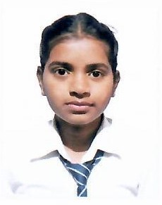

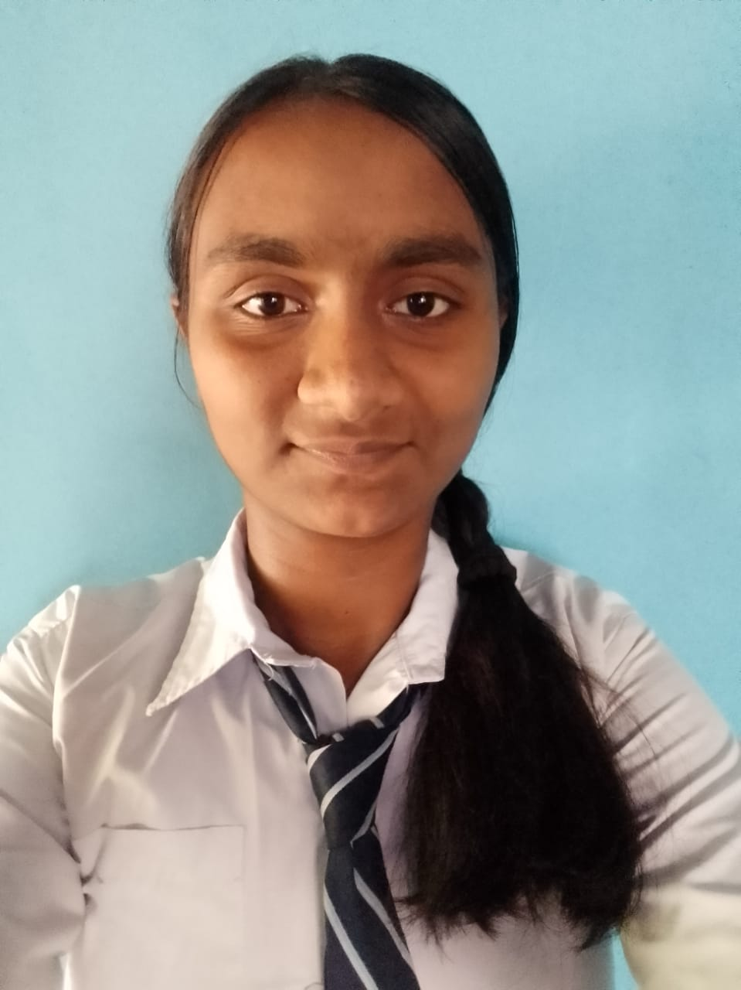

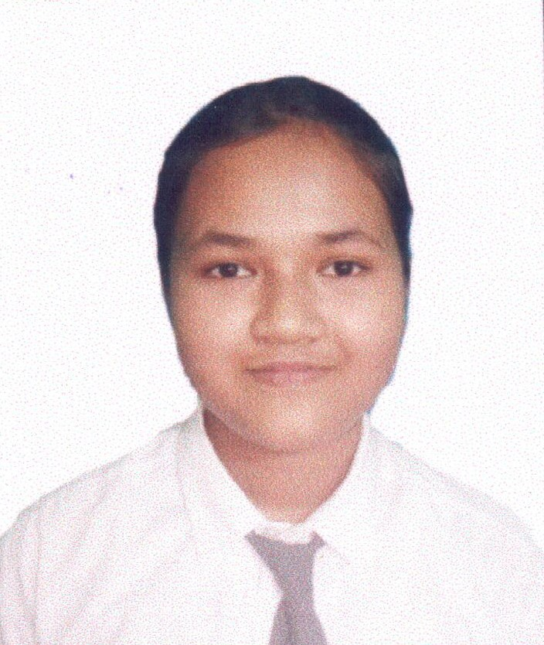

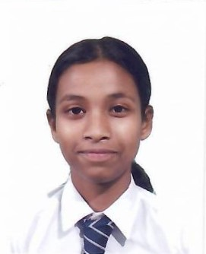

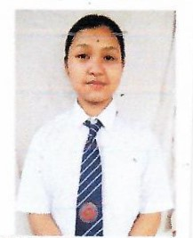

**Palky Gogoi Progoti Deep Sneha Gogoi Jyoti Barhoi Principriya Gogoi Riya Barhoi**

**69% 68.83% 68.67% 68.67% 68.17% 68.17%**

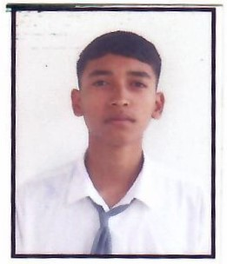

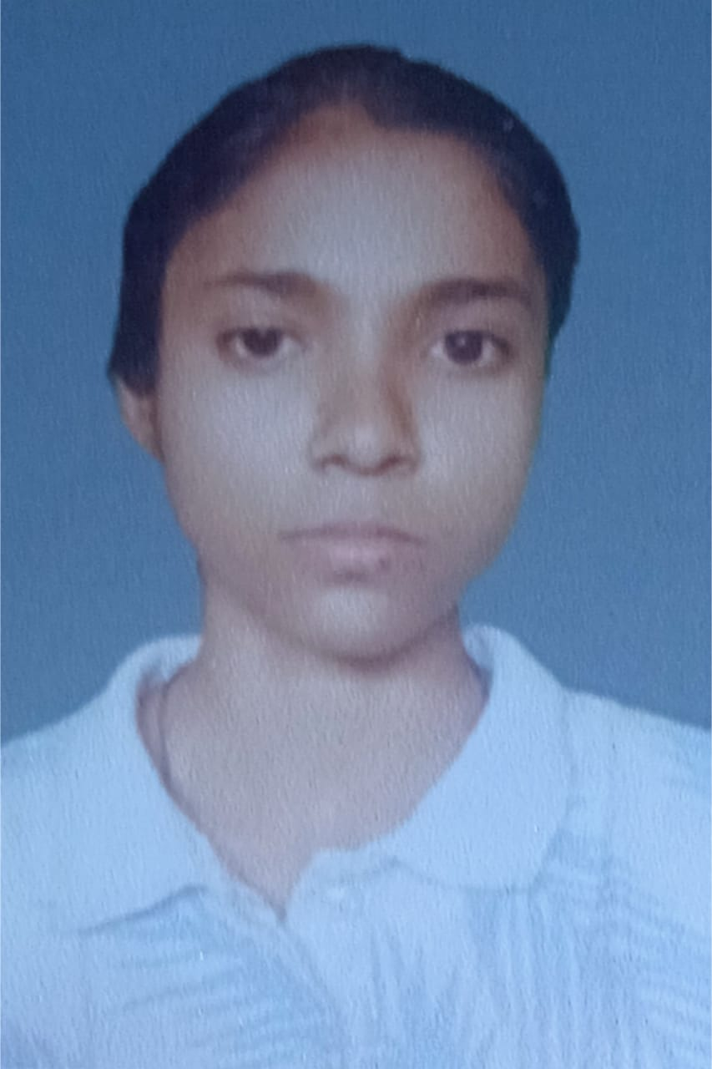

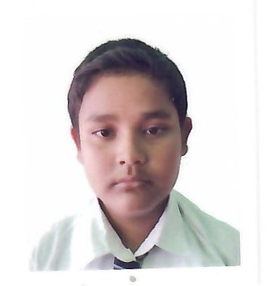

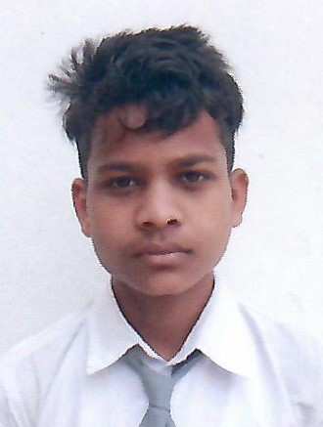

**Arpan Gogoi Nishigandha Gogoi Dipu Gogoi Horen Kurmi**

**66.5% 63.33% 62.67% 62%**